P R E S S R E L E A S E
For immediate release
18th November 2016

JOINT CYBER-CRIME CONFERENCE HELPS CHARITIES
PROTECT AGAINST CYBER-ATTACK

A cyber security conference organised by Tom Floyd DL, the High Sheriff of Hampshire and Chairman of the Hampshire and Isle of Wight Community Foundation (HIWCF) was held at St John’s House in Winchester on 10th November 2016. The event was a joint initiative between Action Hampshire, HIWCF, Hampshire Constabulary, Fixers, Southampton University and Vermont to help smaller charities and voluntary organisations protect themselves against the threat of cyber-crime. Over 70 participants attended from organisations across Hampshire, with a closing speech by the Mayor of Winchester Cllr Jane Rutter.

In 2014, £1.2 billion of direct debit donations were made to charity, providing a huge temptation to criminals perceiving charities and voluntary groups to be an easy target. Smaller voluntary organisations and community groups don’t often have the financial or staff resources to protect themselves against cyber-attack and can find their customer database held to ransom, their website forced offline or they may suffer loss of access to emails or business-critical data. The impact on charities following a cyber-attack can be immense, involving loss of funds, valuable staff resources wasted trying to resolve the situation, and donors potentially losing their trust in that organisation.

Figures from the Office of National Statistics indicate that fraud and computer misuse accounting for 5.8 million crimes in 2015 and showed a further sharp increase in the first half of 2016. Detective Chief Superintendent Ben Snuggs is responsible for Cyber-Crime, Digital Investigation and Intelligence at Hampshire Constabulary and gave an insight into the world of cyber-crime, explaining that in order to defend your organisation, mind-set is absolutely key. Staff must be willing and prepared to protect themselves through adequate training and regular auditing of systems, update of software patches, reporting of suspicious activities. Implementation of Cyber-Essentials, a scheme designed by the Government, will help to prevent the most common types of cyber-attack.

As new technology emerges, single minded criminals are adept at quickly exploiting any vulnerabilities. Neil MacEwan of Southampton University presented a case study on a recent cyber-attack against event organisers Action Hampshire, where access to vital business data was only unlocked once a ransom of almost £500 had been paid to faceless cyber-criminals.

Tom Floyd, High Sheriff of Hampshire and Chairman of HIWCF said “My work with the Community Foundation has been a key trigger for today’s conference, as the smaller charities we support can ill afford the total disruption that a cyber-attack generates. Our aim is to help these groups to protect themselves, and we are offering grants of £200 through HIWCF for smaller voluntary and community groups to achieve Cyber Essentials accreditation. Cyber Essentials will not only enhance protection but also enables organisations to demonstrate that they are taking the risk seriously”.

Ian Glover, President of Crest advised that “In order to gain Cyber Essentials certification, an organisation must complete a self-assessment questionnaire which is then verified by an independent Certification Body, this costs £300 approximately and if you would like to get your organisation assessed, please contact one of the Cyber Essentials Accreditation
Bodies. Contacts are available on www.cesg.gov.uk/servicecatalogue/cyber-essentials.aspx to discuss your requirements and identify a Certification Body to carry out the assessment”.

Please see the HIWCF website to apply for a Cyber Essentials grant for your organisation: www.hantscf.org.uk
The presentations from last week's Cyber Security Conference are currently available from www.actionhampshire.org.uk
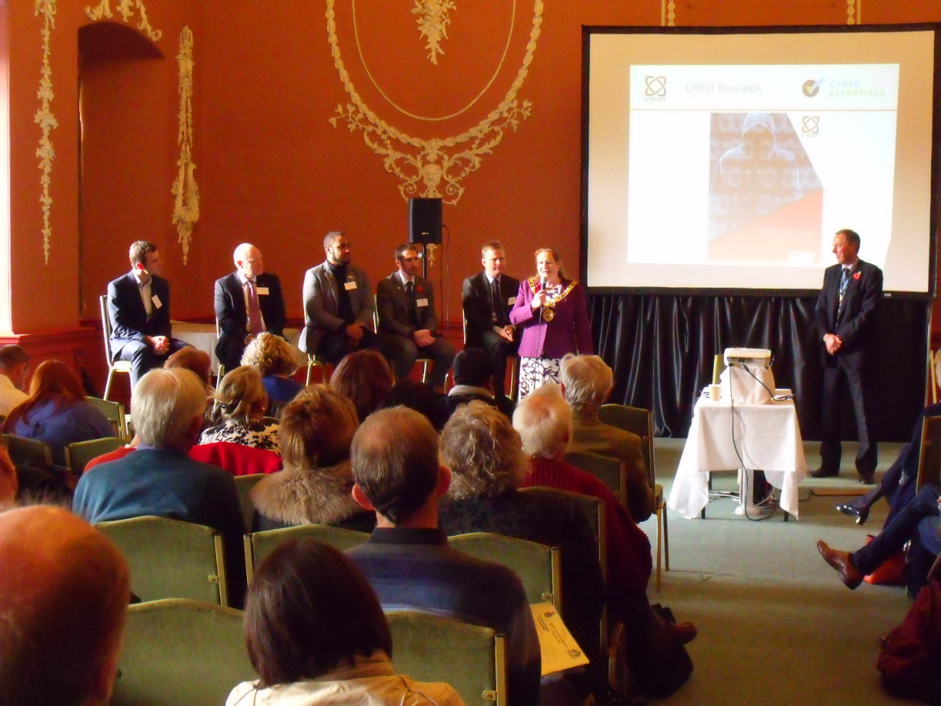

The photograph shows the Mayor of Winchester Cllr Jane Rutter speaking, and from left to right the speakers at the event: Christ Ward of Vermont, Ian Glover of Crest, Carney Bonner of Fixers, DCS Ben Snuggs of Hampshire Constabulary, Neil MacEwan of Southampton University and on the right-hand side Tom Floyd, High Sheriff of Hampshire and Chairman of HIWCF.

- ENDS –

NOTES TO EDITORS

Contact details for Editor:

Name: Lucy Sweet
Title: Marketing Manager
Organisation: HIWCF
Telephone: (01256) 776101
Direct Dial: (01256) 776116
Email: marketing@hantscf.org.uk

About Hampshire and Isle of Wight Community Foundation
Registered Charity No: 1100417

The Hampshire and Isle of Wight Community Foundation is one of 46 UK Community Foundations. Our focus is on the smaller, lesser known, community and voluntary groups working on the frontline in our communities who often only need a few hundred pounds to make a difference to local people’s lives but they struggle to raise these funds. Local groups can take a look at the HIWCF website to see if they might qualify for a grant www.hantscf.org.uk or email HIWCF at grantsadmin@hantscf.org.uk
About UKCF
UKCF is the membership organisation for Community Foundations that work across the UK to raise then distribute money directly to local causes. Community Foundations operate to ensure any form of philanthropy, whether from an individual or an organisation, is effective and brings greatest benefit to those in need in our local communities. Last year, Community Foundations made over 20,000 grants, distributing over £70 million to local causes. Community Foundations’ total managed endowment stood at £500 million in March 2015. We represent 46 quality accredited Community Foundation members. Our Quality Accreditation process is endorsed by the Charity Commission and uses standards consistent with the Charity Commission's Hallmarks of an Effective Charity, with robust, transparent and fair assessment processes. Achieving Quality Accreditation demonstrates that community foundations are serious about quality and accountability.

